**Assignment 2:**

**Stereo Matching**

Ben Solomon 204454615

Din Carmon 209325026

1. Calculating ssdd for the below recrified images and dsp_range=2:

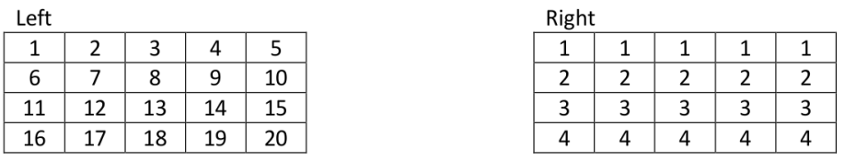

|  |  |  |
| --- | --- | --- |
| 2-1 | 3-1 | 4-1 |
| 7-2 | 8-2 | 9-2 |
| 12-3 | 13-3 | 14-3 |

1. For $ssdd\left(1,2,2\right)$, disparity value = 0. Differences:
$$ssdd\left(1,2,2\right)= 1+2^{2}+3^{2}+5^{2}+6^{2}+7^{2}+9^{2}+{10}^{2}+{11}^{2}=426$$

2. For $ssdd\left(1,2,3\right)$, disparity value = 1. Differences:

|  |  |  |
| --- | --- | --- |
| 2-1 | 3-1 | 4-1 |
| 7-2 | 8-2 | 9-2 |
| 12-3 | 13-3 | 14-3 |

$$ssdd\left(1,2,3\right)=1+2^{2}+3^{2}+5^{2}+6^{2}+7^{2}+9^{2}+{10}^{2}+{11}^{2}=426$$

1. For $ssdd\left(2,3,0\right)$, disparity value = -2. Differences:

|  |  |  |
| --- | --- | --- |
| 8-2 | 9-2 | 10-2 |
| 13-3 | 14-3 | 15-3 |
| 18-4 | 19-4 | 20-4 |

$$ssdd\left(2,3,0\right)=6^{2}+7^{2}+8^{2}+{10}^{2}+{11}^{2}+{12}^{2}+{14}^{2}+{15}^{2}+{16}^{2}=1191$$

1. For $ssdd\left(2,3,1\right)$, disparity value = -1. Differences:

|  |  |  |
| --- | --- | --- |
| 8-2 | 9-2 | 10-2 |
| 13-3 | 14-3 | 15-3 |
| 18-4 | 19-4 | 20-4 |

$$ssdd\left(2,3,1\right)=6^{2}+7^{2}+8^{2}+{10}^{2}+{11}^{2}+{12}^{2}+{14}^{2}+{15}^{2}+{16}^{2}=1191$$

1. The function ssd_distance is implemented and can be viewed in the python src files.
2. Naive labeling output from the distances tensor:

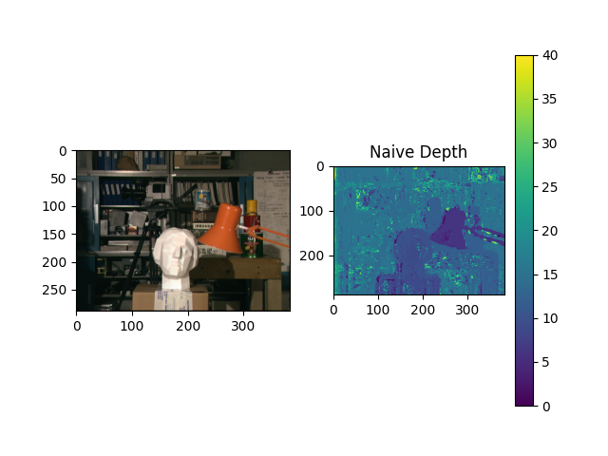

1. The result of the naive depth labeling using the SSDD tensor highlights several issues. Firstly, in areas with repetitive or low-texture patterns (e.g., the background books or monotonic surfaces), multiple local minima arise along the label dimension, leading to incorrect label selection. Naively selecting the minimum often results in suboptimal outcomes, especially in regions with similar objects or lacking distinctive textures. The lack of a smoothness prior worsens the issue, as the method relies solely on local minima, resulting in noisy and inconsistent labels for objects with uniform depth, as seen in Section 3 of the depth map. Additionally, fixed parameters, such as window size, restrict the algorithm's adaptability and reduce accuracy. This can be observed below, where pixels are incorrectly mapped, introducing noise into the forward-mapped image.

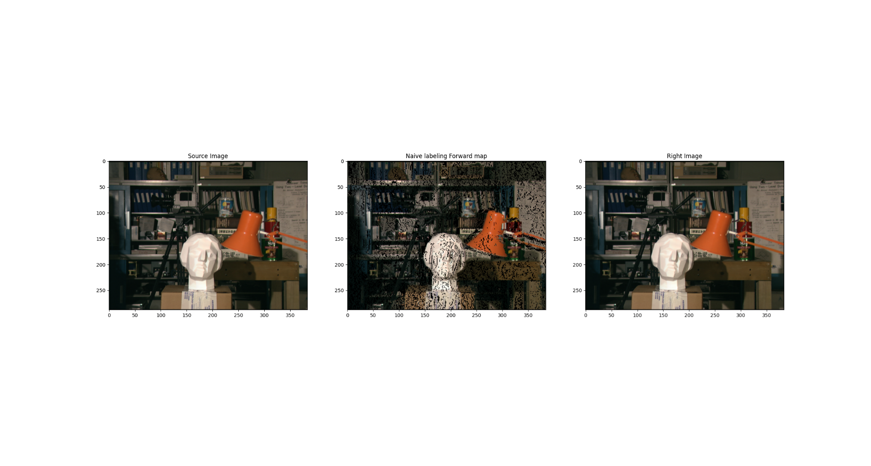

1. The function **dp_grade_slice** is implemented and can be viewed in the python src files.
2. Dynamic Programming labeling output:

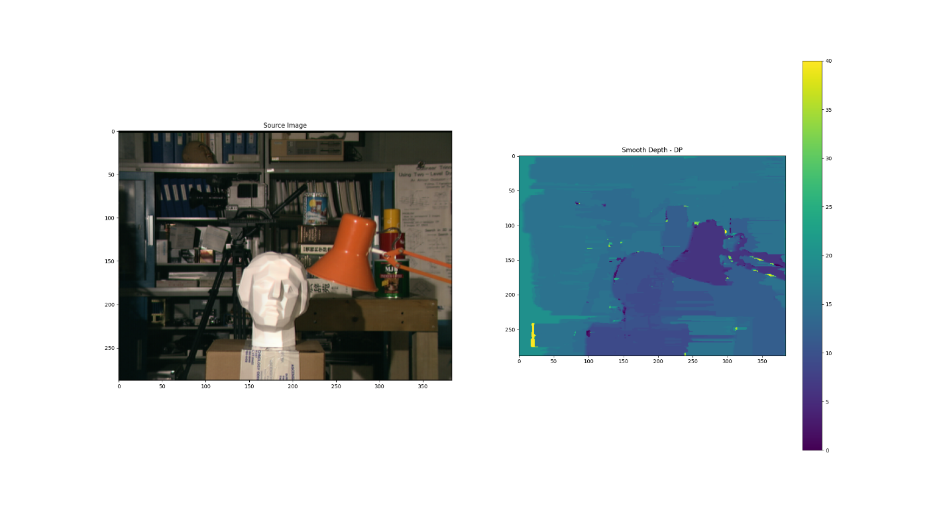

1. 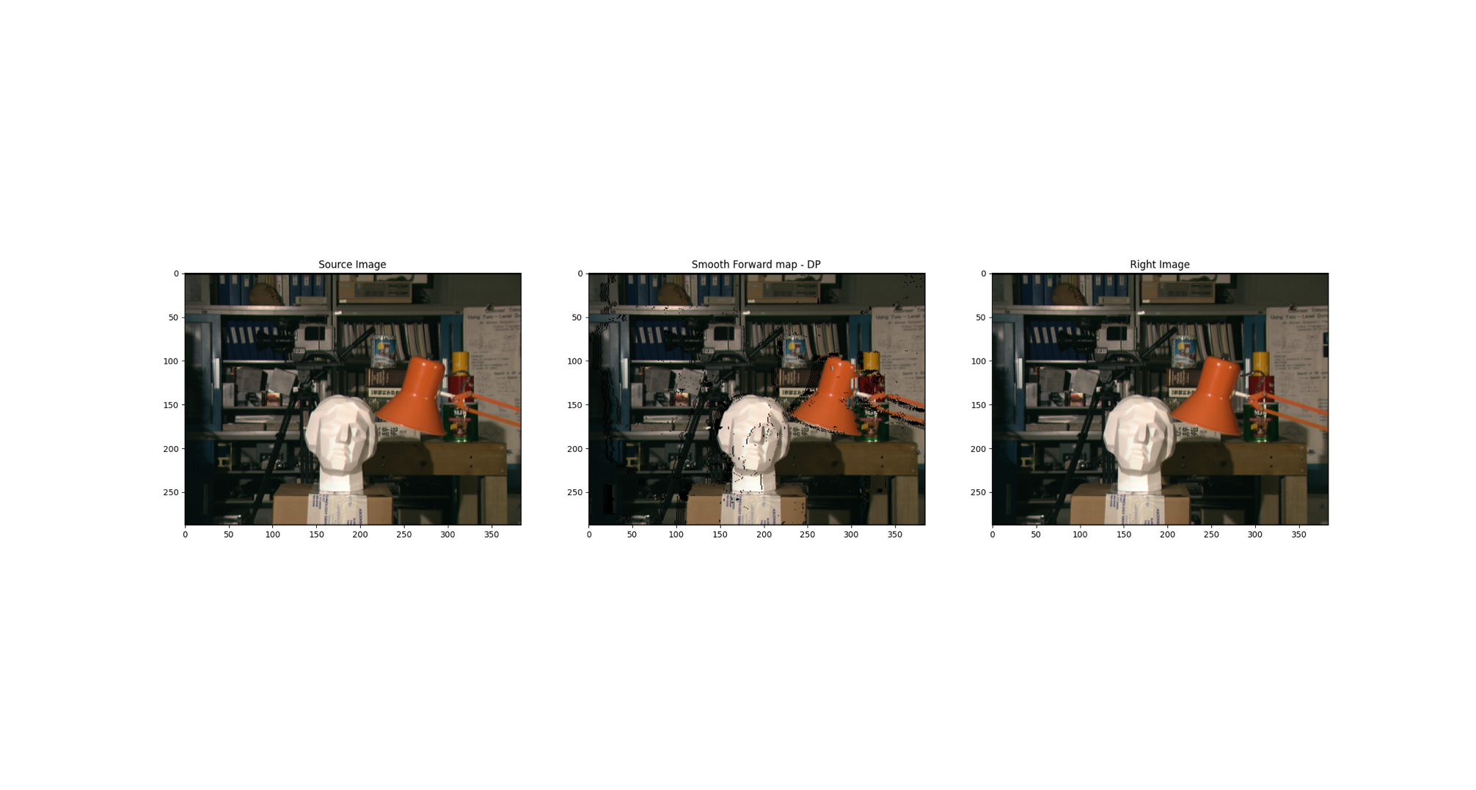The depth map from section 6 is much smoother than the naive map (shown in section 3, 4) because it solves each line optimally and incorporates the **smoothness prior** used in the dynamic programming method. This results in fewer mismatches and less noise in the forward-mapped image, aligning it more closely with the right image, as can be seen below. However, since the DP method solves each line independently rather than inducing some dependency between each line solution, some artifacts and inconsistencies between lines still cause mismatches in the forward map. In addition, we see a side effect of smearing from left to right, the same direction we conducted the dynamic programming smoothing in. The smearing is caused due to the induced penalty of inconsistency in depth which causes the algorithm to prefer the smearing in some points and areas.
2. A method with the name **dp_get_direction_slices(self, ssdd_tensor: np.ndarray, direction: int)** was built and can be viewed in the python source files.
3. The method **dp_grade_slice(…)** can be used with a slice of every valid size. We implemented another method called **build_matrix_from_slices(…)** which is used to build a matrix of size HxWx(#Labels) from the graded slices of different sizes.
4. The function **sgm_labeling** is implemented and can be viewed in the python src files.
5. Using SGM labeling we received the following results:





Now, the smearing side effect is not present due to an averaging of the labeling process done in different directions. In addition, the line edges of objects such as the camera / the nose of the sculpture are much more visible in the depth map.

1. The method **dp_labeling_per_direction(…)** was implemented and can be viewed in the python src files. The function output for the sample images is added here. It is clear to see the different smearing effect direction matching the direction of the labeling process.



1. We used another image from the recommended source given. The results:







1. We propose another metric to measure distances between windows, using the implemented method **ncc_distance(…)**. The method uses a **normalized cross correlation** metric which can be computed as so:

$$NCC\left(u, v\right)=\frac{\sum_{\left(x,y\right)∈windows}{(I_{1}\left[x_{u}+x,y_{u}+y\right]-\overline{I_{1}})(I_{2}\left[x_{v}+x,y_{v}+y\right]-\overline{I_{2}})}}{\sqrt{\sum_{\left(x,y\right)∈windows}{{\left(I_{1}\left[x_{u}+x,y_{u}+y\right]-\overline{I_{1}}\right)}^{2}}}\sqrt{\sum_{\left(x,y\right)∈windows}{{\left(I_{2}\left[x_{v}+x,y_{v}+y\right]-\overline{I_{2}}\right)}^{2}}}}$$

It should be noted that for the following metric we are looking for a depth corresponding to the argmax of NCC (or as implemented to the argmin of -NCC).

This metric has the following advantages:

• Invariant to linear changes in intensity (e.g., due to lighting changes).

* Good for high-texture regions.

However:

• It is computationally more expensive.

• It requires normalization, which can amplify noise.

The naïve labeling using this metric:



The smooth depth labeling using dynamic programming in one direction:





Running smooth labeling algorithm in different directions:



And finally averaging the solutions, yields the SGM solution:





From the result, we can see that the results are much more noisy, as was expected from theory.

The results are so noisy, that smearing effect is almost not visible due to the noise taking a bigger effect on the minimization process than the smoothness prior. Overrunning the parameter of the algorithm may yield better results.

1. We chose to solve the labeling problem using the min-cut/max-flow algorithm and the alpha-expansion approach. It includes:

* Unary terms: derived from the SSD tensor to define the data cost
* Binary terms: define cost between neighboring pixels to gain smoothness constraints
* Alpha-expansion: Iteratively refines the depth map by optimizing for each label (disparity level)

The algorithm:

1. Normalize ssd_tensor costs to [0,1]
2. Initialize naïve labeling (smallest SSD value for each pixel)
3. Loop alpha over labels
   1. Construct graph such that
      1. Node “Source”, which means change the label to alpha
      2. Node “Sink”, which means keep the current label
      3. Node for each pixel $p_{i,j}=\left(i,j\right)∈\left(H,W\right)$
      4. For each pixel $p_{i,j}$ add edge $(source, p_{i,j})$ with capacity

$e^{-{\left(cost_alpha\right)}^{2}}$ where cost_alpha is the ssd_tensor value of

* + 1. For each pixel $p_{i,j}$ add edge $(p_{i,j},sink)$ with capacity

$e^{-{\left(cost_current\right)}^{2}}$ where cost_current is the ssd_tensor value of $(i,j,label)$ where label is the current label of pixel (i,j).

Note that after some optimization tests we chose to set capacity 0 for the edge $(p_{i,j},sink)$ in case current label is equal to alpha, to encourage such pixel to be associated with the “Sink” node and also encourage its neighbors to update label if needed.

* + 1. For each pixel $p_{i,j}$ add edges to its neighbors $(p_{i,j}, p_{i+1,j})$

And $(p_{i,j}, p_{i,j+1})$ with capacity 0.00001 (this value had great balance between smoothness and data values. Those edges allows to plug in the smoothness prior and get smooth depth image. Several capacity heuristics between neighbors pixels have been tried, including checking the distance between neighboring pixel labels. Finally constant value brought us the best results.

* 1. Run the min-cut/max-flow algorithm on the constructed graph. We used networkx library to construct the graph and running the algorithm. The output of the algorithm is (A,B) partition, where A are pixels in the “Source” group and B pixels from the “Sink” group.
  2. Finally, for each pixel in group A (pixels in the “Source” group), update label to alpha

1. Actually, the algorithm optimally should run several epochs, but even one epoch gained good results. This is possibly caused by the first good “guess” of the naïve labeling.

Results:

The initial depth labels are the smallest SSD tensor values (such the naïve labeling from previous parts):

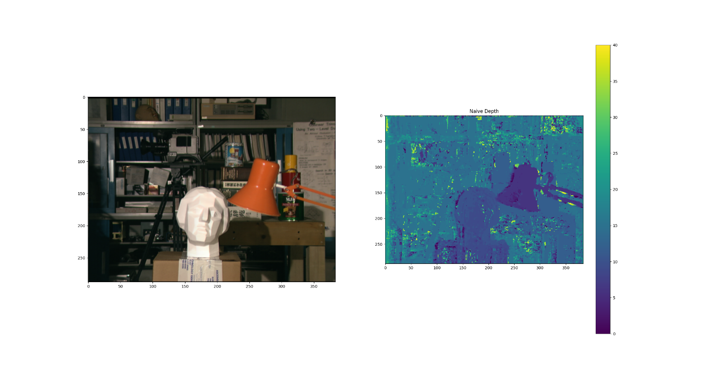

We ran the algorithm with DISPARITY_RANGE=20. We have 41 possible labels, and 41 alpha-expansion iterations. Here are some intermediate outputs for alpha=[10, 20, 30]:

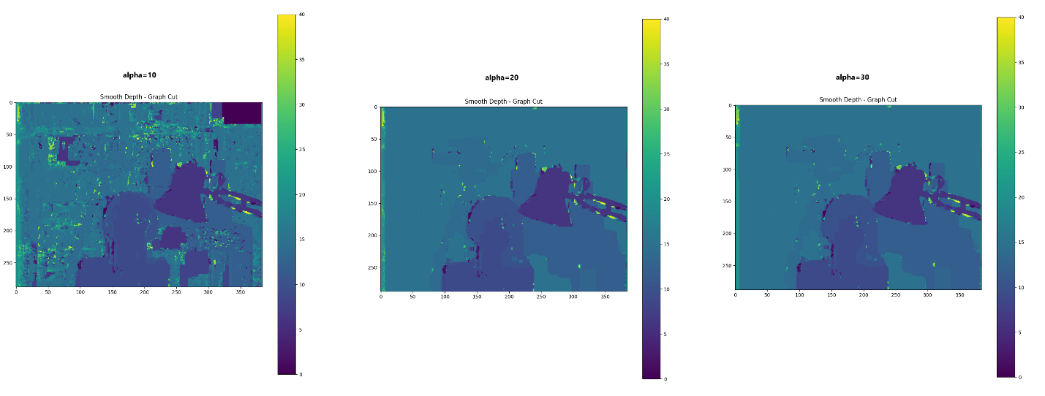

As can be seen, as the algorithm keep iterating and updating labels to alpha, the smoothness improves.

Finally after all iterations, we got result which is pretty similar to the one we achieved with the SGM result:

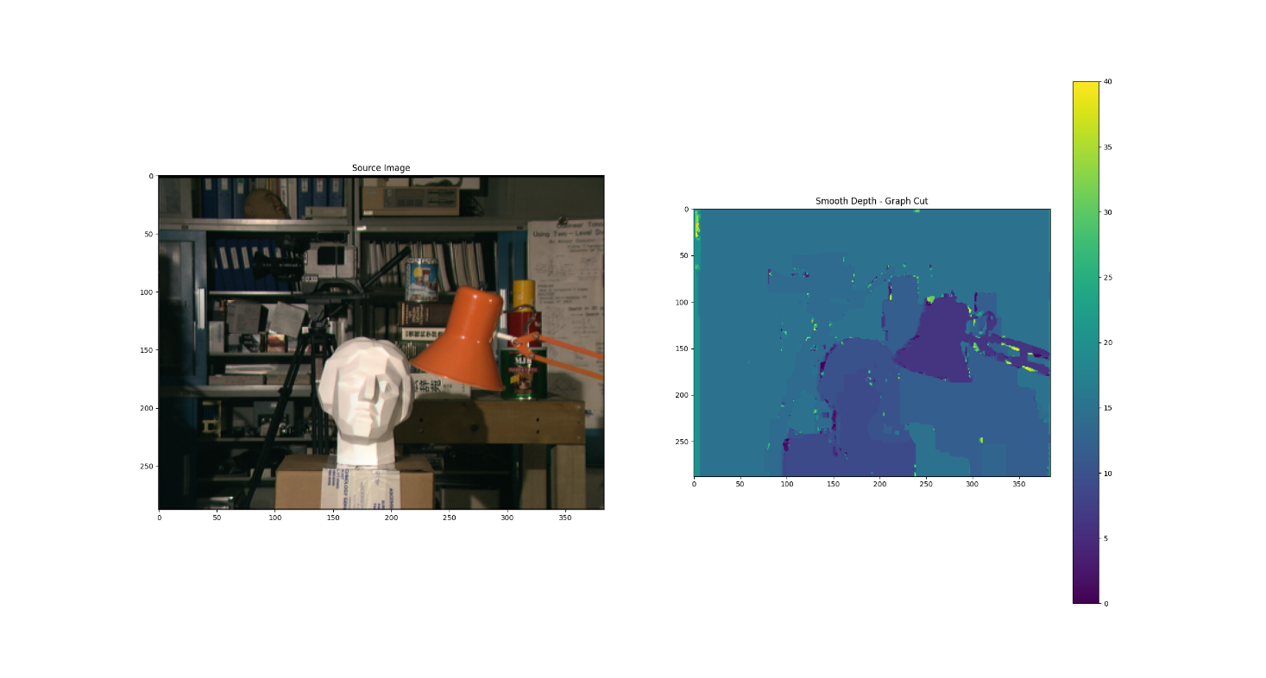

Testing with the forward map reveals some artifacts caused by disparity mismatches, resembling those observed in the results of the SGM labeling.

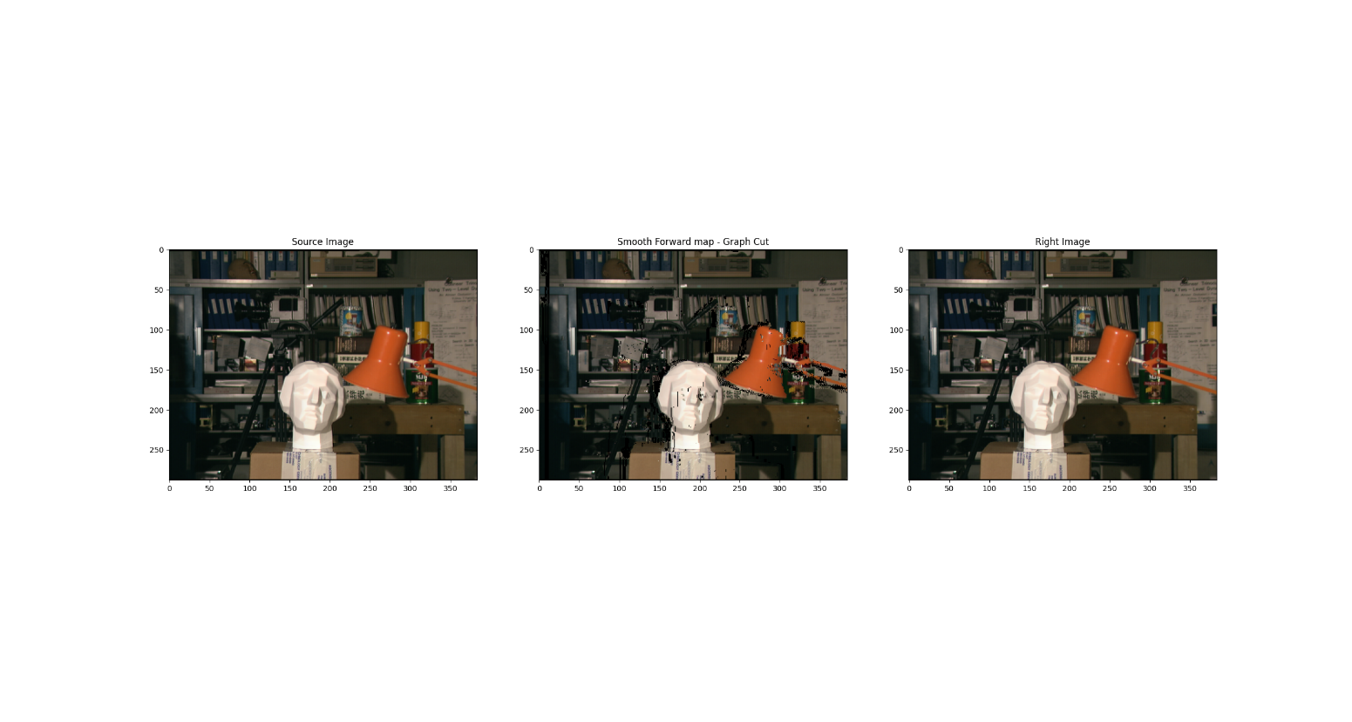

1. As mentioned in Section 15, the result of the Graph-Cut depth labeling is pretty similar to the result of the SGM labeling. The Graph-Cut labelling achieved higher accuracy around object boundaries, as the binary terms enforce smoothness while respecting abrupt changes when data costs (unary terms) dominate.

In the other hand, The SGM smoothness is a bit better. This can be explained by the fact that we used one epoch of alpha-expansion update. In addition, the Graph-Cut algorithm is influenced by graph construction decisions (which defines how the algorithm refers to neighbours) and fixed parameters such as edges cost which restrict the algorithm's adaptability and reduce accuracy. In addition, the SGM method is much faster and consume less computational resources (Graph-Cut method is dependent on disparity range).